Cate Cinti

ENGCMP 0610

September 30, 2024

Soundscape Narrative: Creator’s Statement

For my soundscape narrative, I’m documenting the baking process. The narrative follows a character as they walk into their kitchen searching for a cake recipe. Once they settle on one, they play some music on their phone and start baking. They get their supplies and mix the wet and dry ingredients, scraping everything into a metal pan before placing it in the oven. They set an egg timer and once it goes off, the pan is removed and the cake is cut. The character eats a slice.

This topic is one that interested me when I was considering options for my project. I enjoy baking, and I thought it would be a great opportunity to engage with it! I had some goals to achieve in terms of what I wanted the listener’s experience to be. Firstly, while recording, I discovered that it was quite difficult to capture baking through sound. So, my main goal was to ensure that the audience would be able to clearly visualize what was going on throughout the narrative. My soundscape isn’t very abstract; it’s a linear story, so the listener should understand the step-by-step process using very little narration. Secondly, I want to capture the feelings I get while baking. The soundscape should feel relaxing, exciting, and rewarding.

Moving into the creation and technical aspects, I began the process by recording some of my own sounds in my kitchen and downloading what I couldn’t record from Freesound. My first barrier was just working with Audacity. I have no experience, so just understanding the basics was a major hurdle. After completing the project, I don’t feel totally comfortable with Audacity, but I’ve come a long way. I ran into a few issues while working that required me to use various tools in Audacity…

(1) I applied the **Noise Cancellation** feature after we discussed it in class. Most of my own recorded sounds had some sort of background noise. Noise cancelation helped things flow smoother and removed the distractions from my own recordings, helping them flow with the downloaded recording much better.

**Before Noise Cancellation**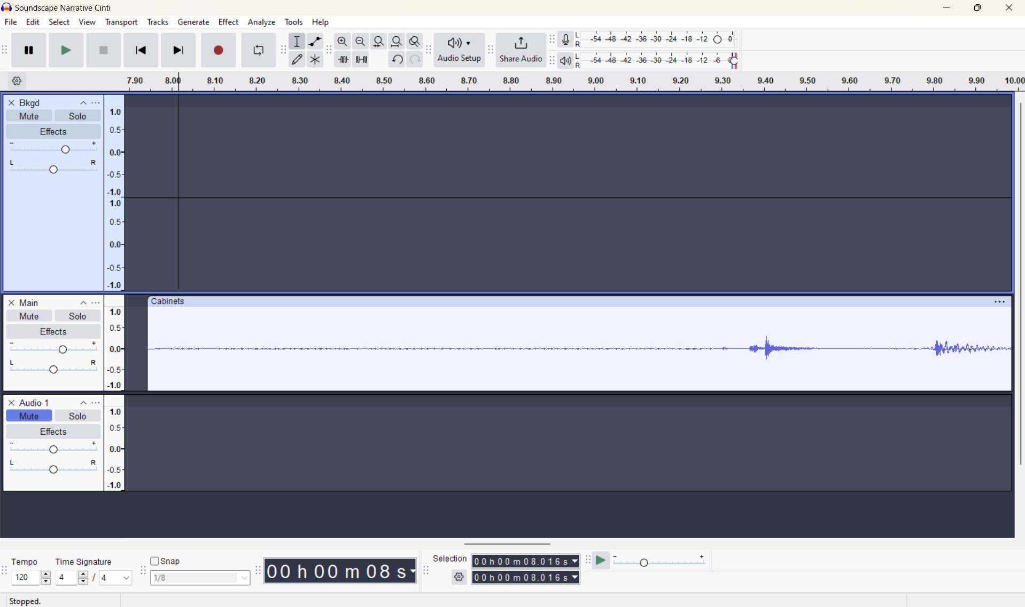

**After Noise Cancellation**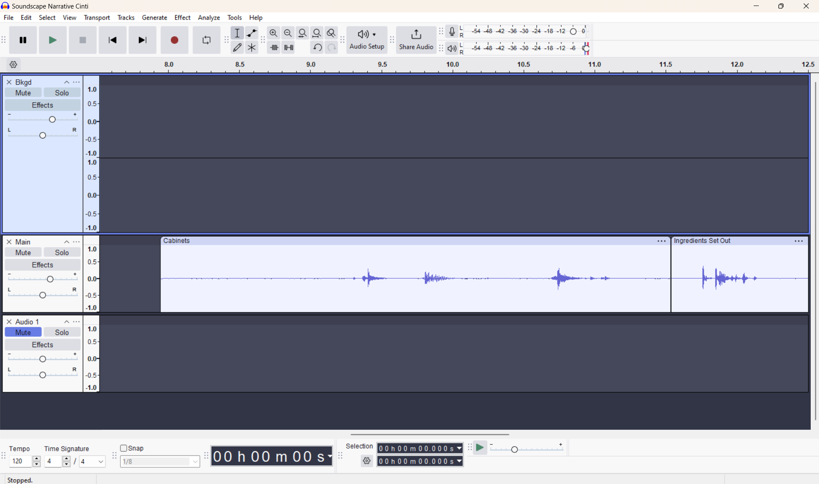

(2) It was difficult to find exactly what I was envisioning on Freesound. I wanted a ticking egg timer that would go off, but all I could find was the ringing sound by itself and a wind-up/ticking sound (I didn’t want any wind-up). I cut up the sounds and used the **Join** feature to combine these two to get exactly what I wanted.

**Before Join**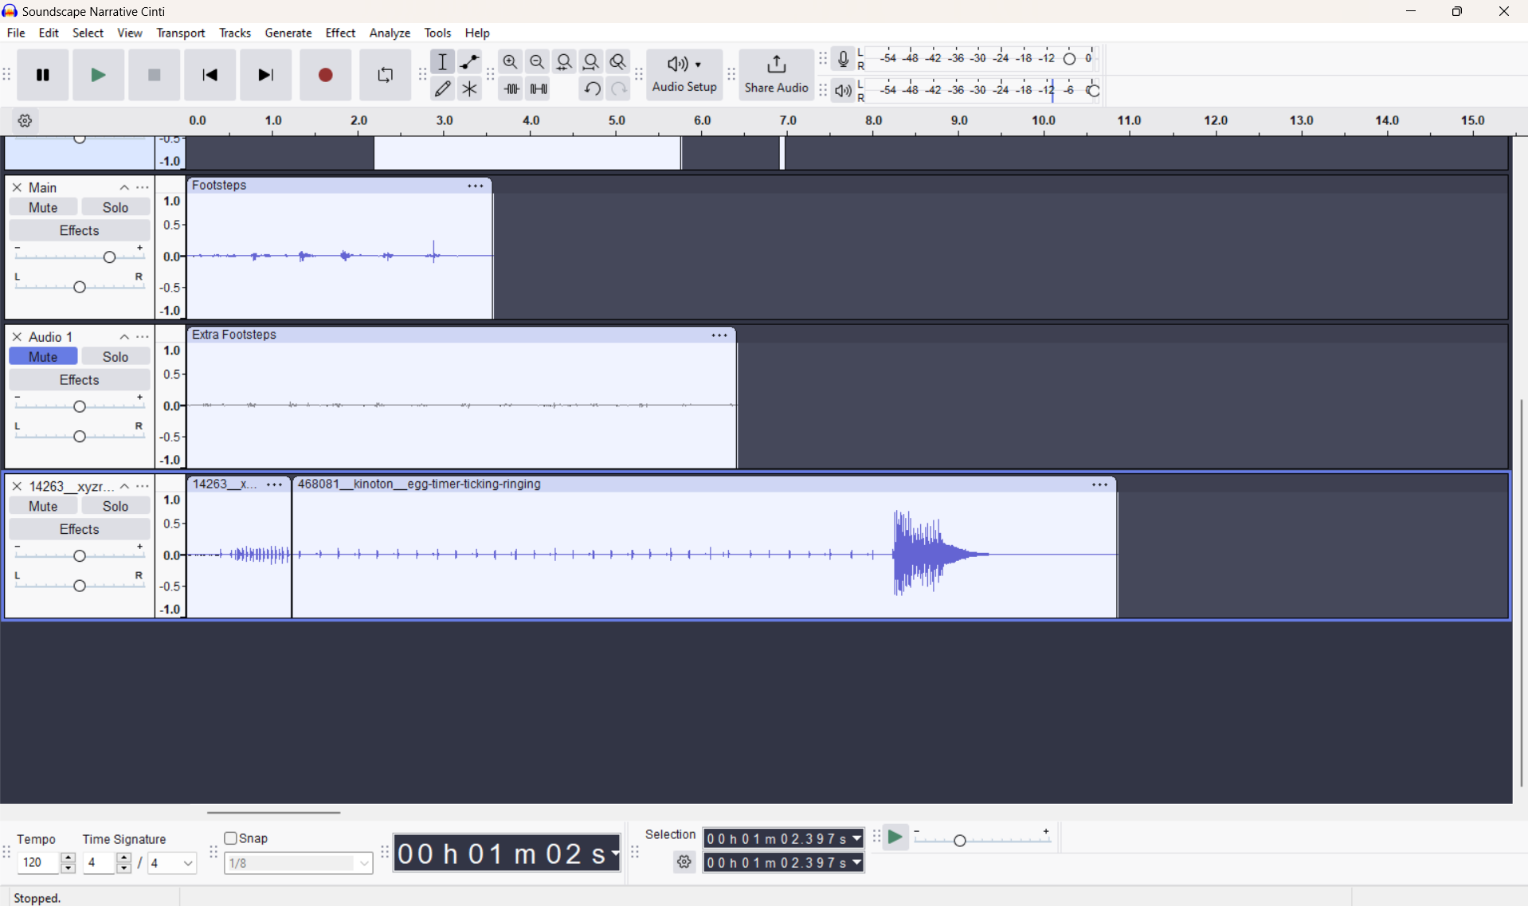

**After Join**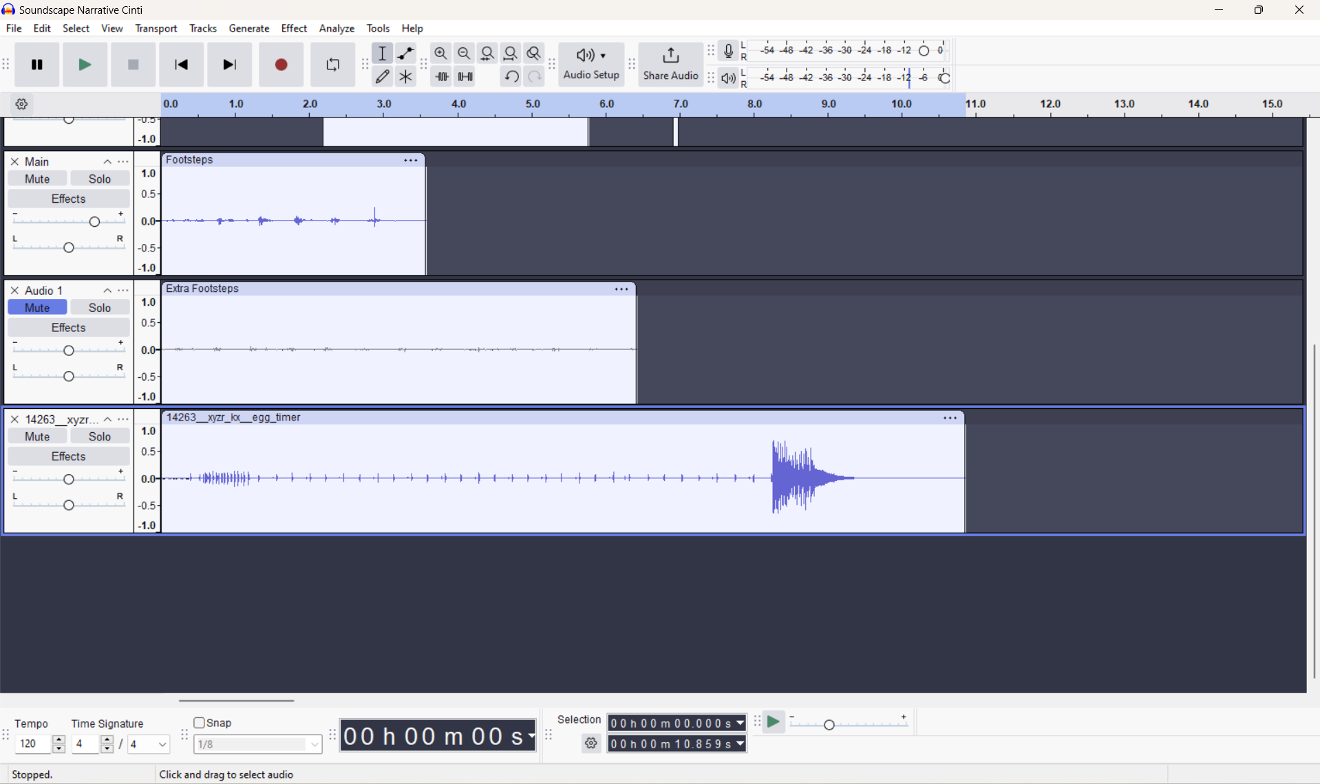

(3) I wanted the character’s music to fade and come back at the end. This would add a cinematic touch and make it so nothing overpowers the baking sounds. I used the **Envelope** feature we learned in class to achieve this.

**Before Envelope**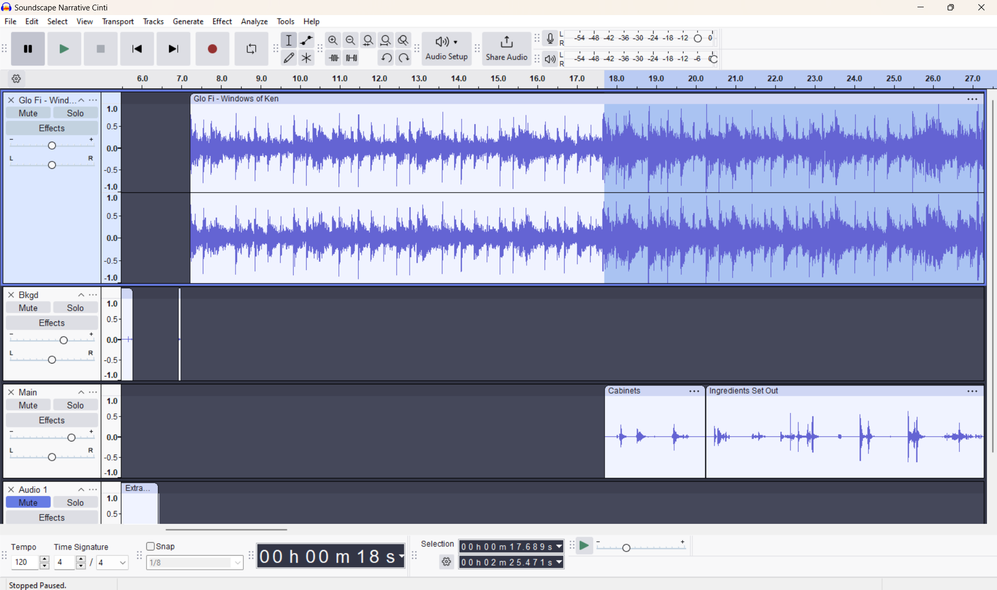

**After Envelope**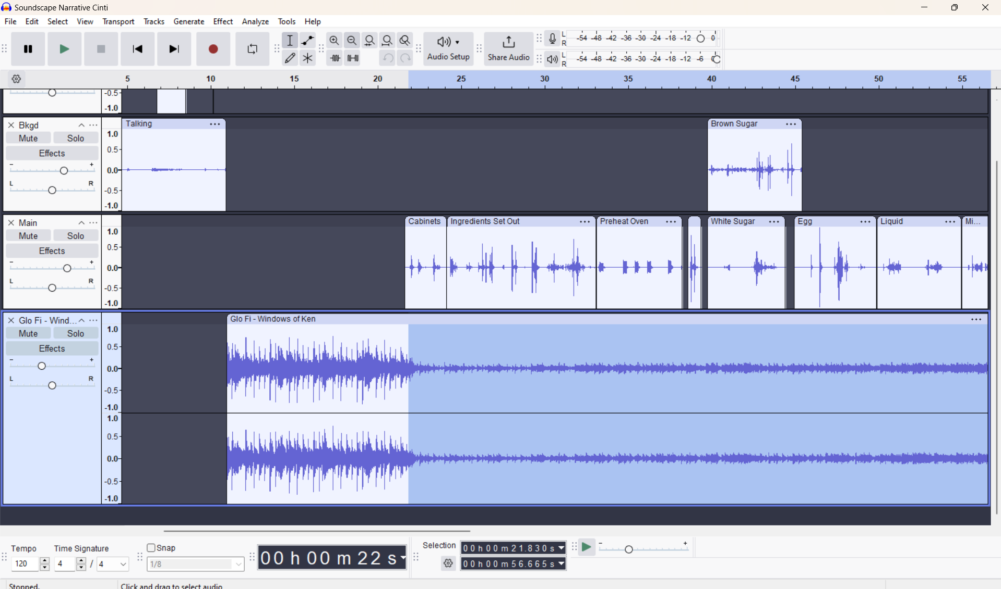

I tried to capture the feeling I get through backing using the music, and the Audacity tools helped me overcome many problems along the way. My sounds and editing choices add depth.